**Design Overview:**

A two-channel mixer takes the input voltage from an AC source, applies gain to each one based on the two control knobs/sliders, and then combines them into a single output signal. Op-amps are particularly useful in creating these, as a feedback resistor can be used as reference for variable resistors to calculate the gain of each input signal from. This was the premise of this design project. A second version of this circuit contains another op-amp with a shorted feedback loop to restore the polarity of the inverted signal back to its original polarity.

**Design Details:**

Version 1 (Using Absolute Value of Equation):

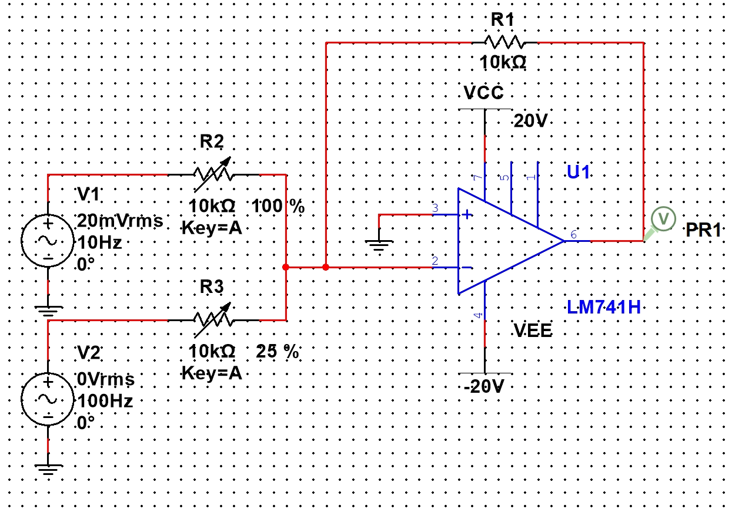

Proof with Calculations:

$A_{1}=\frac{R_{1}}{R_{2}}=\frac{10000 Ω}{10000 Ω}=1$

$A_{1}=\frac{R_{1}}{R_{2}}=\frac{10000 Ω}{0.25(10000 Ω)}=\frac{10000 Ω}{2500 Ω}=4$

$|V(t)|=|-(A_{1}V_{1}+A_{2}V_{2})|=A_{1}V_{1}+A_{2}V_{2}=V_{1}+4V_{2}$

Version 2 (Using De-inverter):

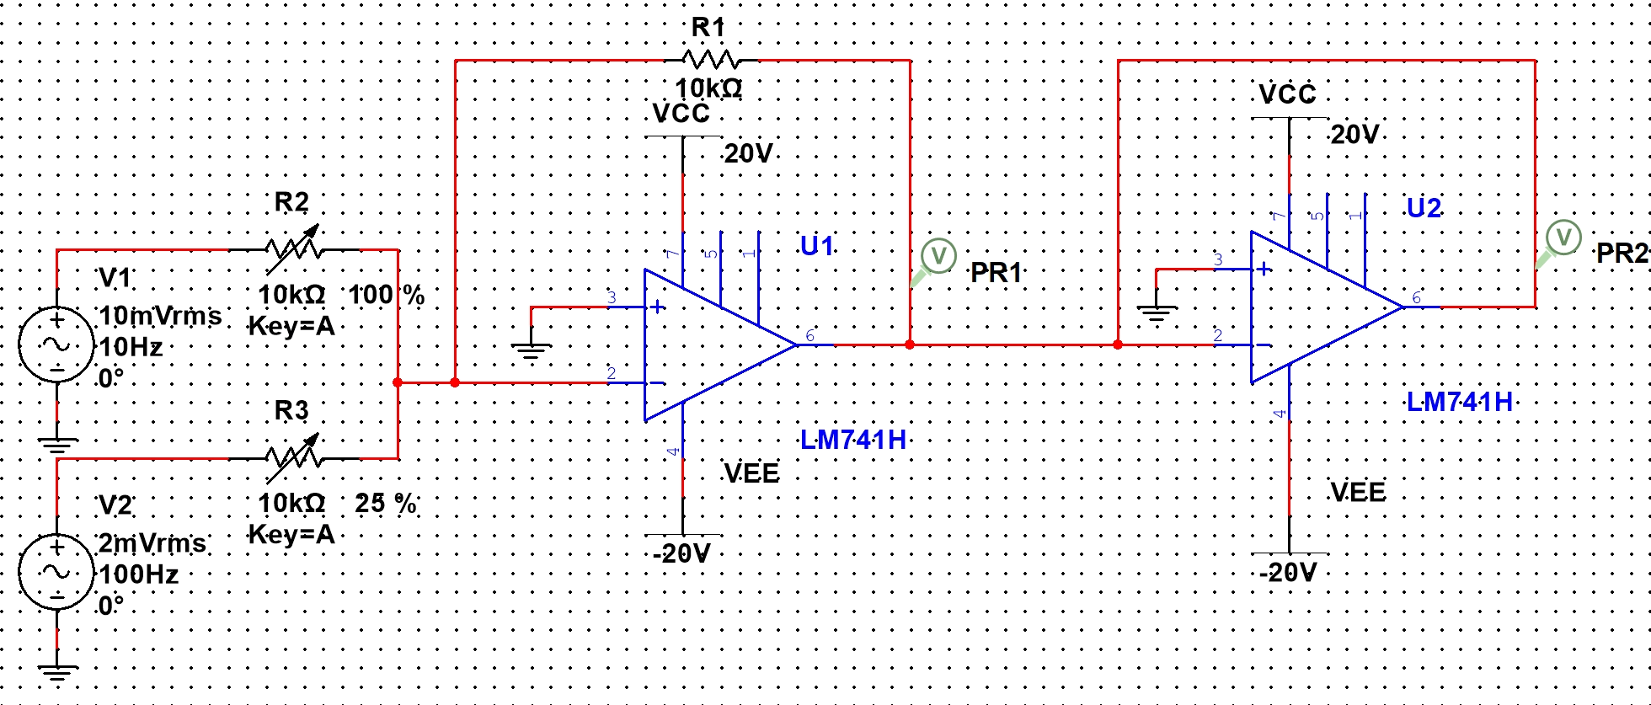

Proof with Calculations:

$A_{1}=\frac{R_{1}}{R_{2}}=\frac{10000 Ω}{10000 Ω}=1$

$A_{1}=\frac{R_{1}}{R_{2}}=\frac{10000 Ω}{0.25(10000 Ω)}=\frac{10000 Ω}{2500 Ω}=4$

$V(t)= -(-(A_{1}V_{1}+A_{2}V_{2}))=A_{1}V_{1}+A_{2}V_{2}=V_{1}+4V_{2}$

Each AC voltage source is an input stream with a particular frequency. Variable resistors, controlled by either knobs or sliders, immediately follow each source, which are used to inversely control the gain of each input. Both of these variable resistors are connected to the inverting input of the gain controlling op-amp, which has a feedback loop containing a $10000 Ω$ resistor. The output signal of this op-amp is then connected to the inverting input of the de-inverting op-amp, which has a short replacing the feedback resistor to ensure that no additional gain is generated. As the first op-amp reverses the polarity of the input signals, this second one is used to restore the output to the original polarity. Both op-amps have ground connected to their non-inverting inputs as well as side connections to the positive and negative power sources.

**Testing:**

V1 Only:

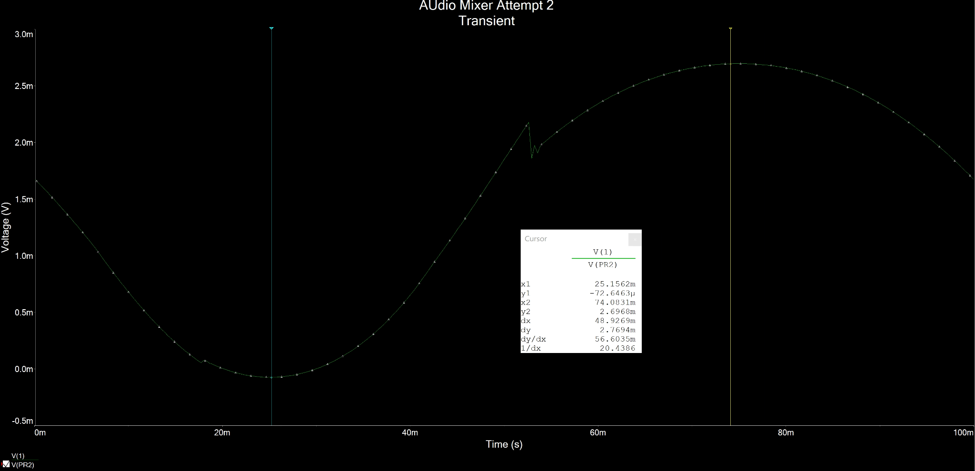

V2 Only:

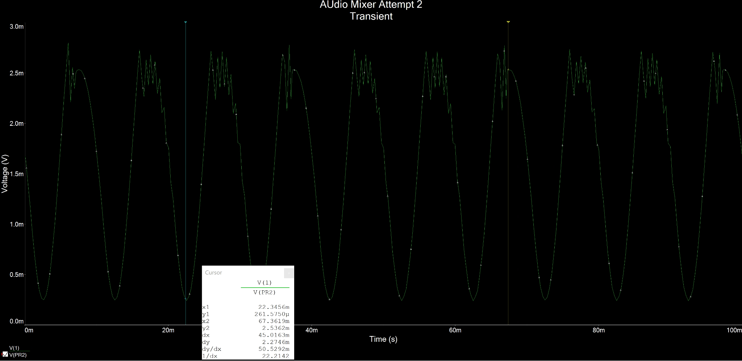

V1 and V2:

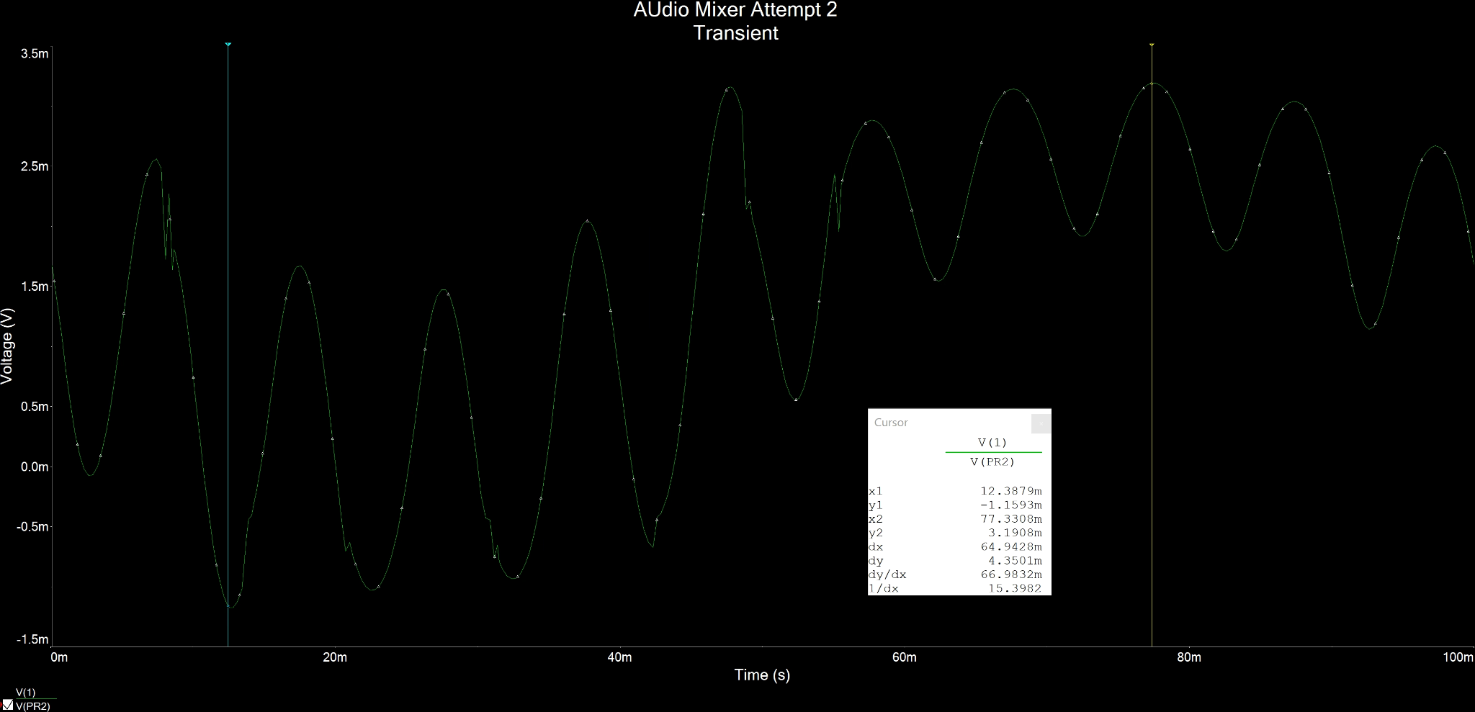

**Conclusion:**

Despite occasional discrepancies in the form of sudden spikes within the output signals, the design still appears to function as specified by the formula $V(t)=A_{1}V_{1}+A_{2}V_{2}$. When both inputs are active, the output has the same primary wave frequency and amplitude of the higher-frequency input, but distorted by the frequency and amplitude of the lower-frequency input. This is the expected behavior of a two-channel mixer when the inputs are sine waves of different frequencies. Therefore, this design for such two-channel mixer is indeed valid.